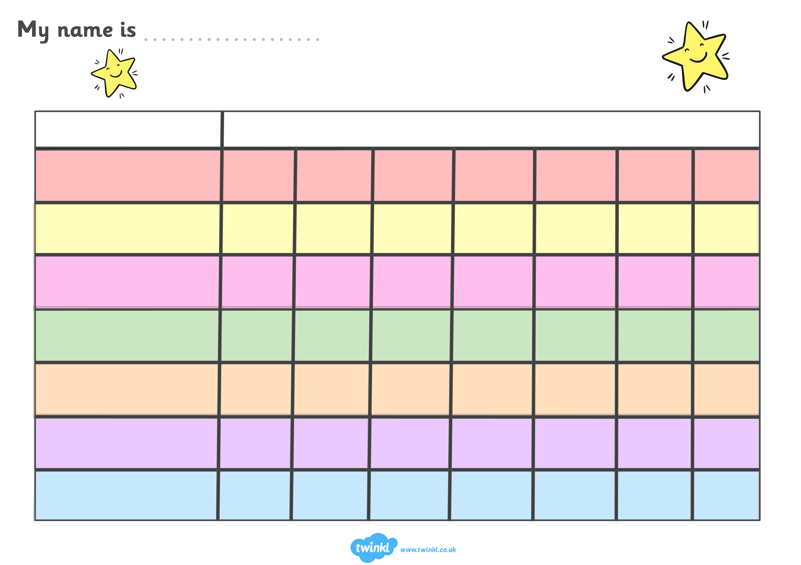–

**AT HOME MONITORING CHART**

What did they have & how much did they eat? *(Please circle: 1 = None – 5 = All)*

Sunday

Saturday

Friday

Thursday

Wednesday

Tuesday

Monday

|  |  |  |  |  |
| --- | --- | --- | --- | --- |
| 1 | 2 | 3 | 4 | 5 |

|  |  |  |  |  |
| --- | --- | --- | --- | --- |
| 1 | 2 | 3 | 4 | 5 |

|  |  |  |  |  |
| --- | --- | --- | --- | --- |
| 1 | 2 | 3 | 4 | 5 |

|  |  |  |  |  |
| --- | --- | --- | --- | --- |
| 1 | 2 | 3 | 4 | 5 |

|  |  |  |  |  |
| --- | --- | --- | --- | --- |
| 1 | 2 | 3 | 4 | 5 |

|  |  |  |  |  |
| --- | --- | --- | --- | --- |
| 1 | 2 | 3 | 4 | 5 |

|  |  |  |  |  |
| --- | --- | --- | --- | --- |
| 1 | 2 | 3 | 4 | 5 |

|  |  |  |  |  |
| --- | --- | --- | --- | --- |
| 1 | 2 | 3 | 4 | 5 |

|  |  |  |  |  |
| --- | --- | --- | --- | --- |
| 1 | 2 | 3 | 4 | 5 |

|  |  |  |  |  |
| --- | --- | --- | --- | --- |
| 1 | 2 | 3 | 4 | 5 |

|  |  |  |  |  |
| --- | --- | --- | --- | --- |
| 1 | 2 | 3 | 4 | 5 |

|  |  |  |  |  |
| --- | --- | --- | --- | --- |
| 1 | 2 | 3 | 4 | 5 |

|  |  |  |  |  |
| --- | --- | --- | --- | --- |
| 1 | 2 | 3 | 4 | 5 |

|  |  |  |  |  |
| --- | --- | --- | --- | --- |
| 1 | 2 | 3 | 4 | 5 |

|  |  |  |  |  |
| --- | --- | --- | --- | --- |
| 1 | 2 | 3 | 4 | 5 |

|  |  |  |  |  |
| --- | --- | --- | --- | --- |
| 1 | 2 | 3 | 4 | 5 |

|  |  |  |  |  |
| --- | --- | --- | --- | --- |
| 1 | 2 | 3 | 4 | 5 |

|  |  |  |  |  |
| --- | --- | --- | --- | --- |
| 1 | 2 | 3 | 4 | 5 |

|  |  |  |  |  |
| --- | --- | --- | --- | --- |
| 1 | 2 | 3 | 4 | 5 |

|  |  |  |  |  |
| --- | --- | --- | --- | --- |
| 1 | 2 | 3 | 4 | 5 |

|  |  |  |  |  |
| --- | --- | --- | --- | --- |
| 1 | 2 | 3 | 4 | 5 |

|  |  |  |  |  |
| --- | --- | --- | --- | --- |
| 1 | 2 | 3 | 4 | 5 |

|  |  |  |  |  |
| --- | --- | --- | --- | --- |
| 1 | 2 | 3 | 4 | 5 |

|  |  |  |  |  |
| --- | --- | --- | --- | --- |
| 1 | 2 | 3 | 4 | 5 |

|  |  |  |  |  |
| --- | --- | --- | --- | --- |
| 1 | 2 | 3 | 4 | 5 |

|  |  |  |  |  |
| --- | --- | --- | --- | --- |
| 1 | 2 | 3 | 4 | 5 |

|  |  |  |  |  |
| --- | --- | --- | --- | --- |
| 1 | 2 | 3 | 4 | 5 |

|  |  |  |  |  |
| --- | --- | --- | --- | --- |
| 1 | 2 | 3 | 4 | 5 |

|  |  |  |  |  |
| --- | --- | --- | --- | --- |
| 1 | 2 | 3 | 4 | 5 |

|  |  |  |  |  |
| --- | --- | --- | --- | --- |
| 1 | 2 | 3 | 4 | 5 |

|  |  |  |  |  |
| --- | --- | --- | --- | --- |
| 1 | 2 | 3 | 4 | 5 |

|  |  |  |  |  |
| --- | --- | --- | --- | --- |
| 1 | 2 | 3 | 4 | 5 |

|  |  |  |  |  |
| --- | --- | --- | --- | --- |
| 1 | 2 | 3 | 4 | 5 |

|  |  |  |  |  |
| --- | --- | --- | --- | --- |
| 1 | 2 | 3 | 4 | 5 |

|  |  |  |  |  |
| --- | --- | --- | --- | --- |
| 1 | 2 | 3 | 4 | 5 |

|  |  |  |  |  |
| --- | --- | --- | --- | --- |
| 1 | 2 | 3 | 4 | 5 |

|  |  |  |  |  |
| --- | --- | --- | --- | --- |
| 1 | 2 | 3 | 4 | 5 |

|  |  |  |  |  |
| --- | --- | --- | --- | --- |
| 1 | 2 | 3 | 4 | 5 |

|  |  |  |  |  |
| --- | --- | --- | --- | --- |
| 1 | 2 | 3 | 4 | 5 |

|  |  |  |  |  |
| --- | --- | --- | --- | --- |
| 1 | 2 | 3 | 4 | 5 |

|  |  |  |  |  |
| --- | --- | --- | --- | --- |
| 1 | 2 | 3 | 4 | 5 |

|  |  |  |  |  |
| --- | --- | --- | --- | --- |
| 1 | 2 | 3 | 4 | 5 |

|  |  |  |  |  |
| --- | --- | --- | --- | --- |
| 1 | 2 | 3 | 4 | 5 |

|  |  |  |  |  |
| --- | --- | --- | --- | --- |
| 1 | 2 | 3 | 4 | 5 |

|  |  |  |  |  |
| --- | --- | --- | --- | --- |
| 1 | 2 | 3 | 4 | 5 |

|  |  |  |  |  |
| --- | --- | --- | --- | --- |
| 1 | 2 | 3 | 4 | 5 |

|  |  |  |  |  |
| --- | --- | --- | --- | --- |
| 1 | 2 | 3 | 4 | 5 |

|  |  |  |  |  |
| --- | --- | --- | --- | --- |
| 1 | 2 | 3 | 4 | 5 |

|  |  |  |  |  |
| --- | --- | --- | --- | --- |
| 1 | 2 | 3 | 4 | 5 |

|  |  |  |  |  |
| --- | --- | --- | --- | --- |
| 1 | 2 | 3 | 4 | 5 |